**Tiết 1- UNIT 2: PERSONAL INFORMATION (THÔNG TIN CÁ NHÂN)**

**A. TELEPHONES**

**A4**

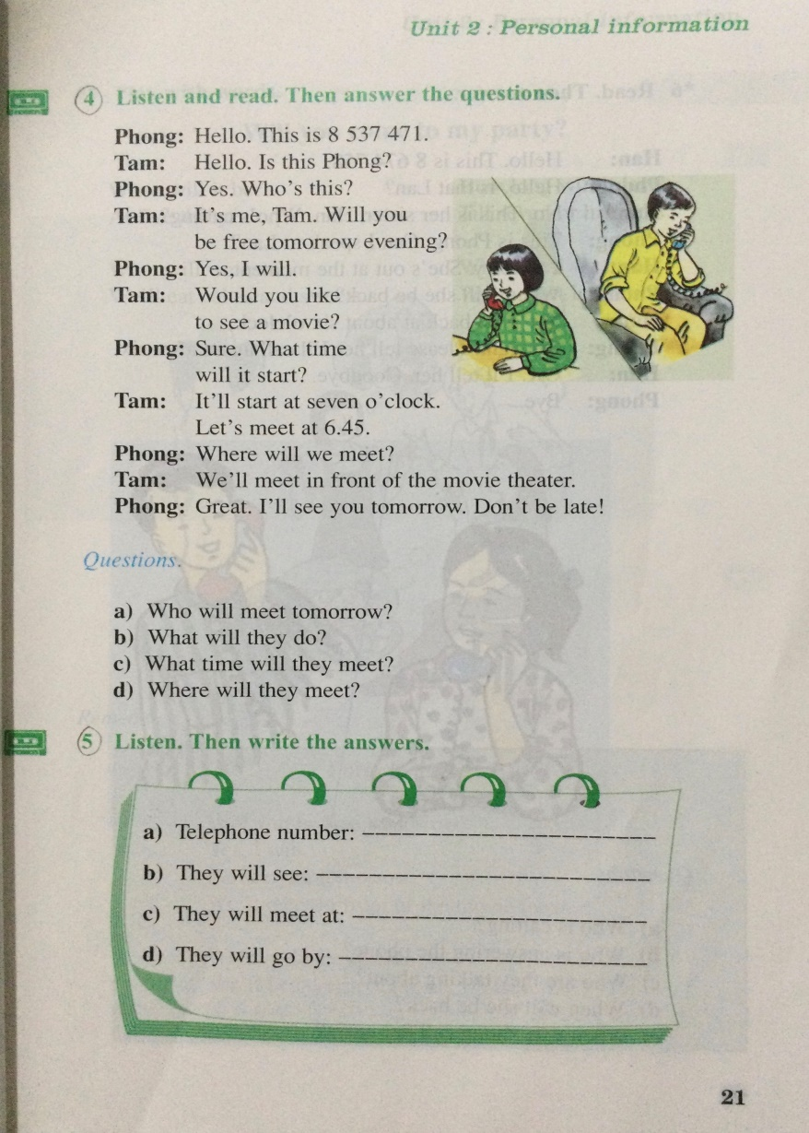

**VOCABULARY**

1. personal (a.) : thuộc về cá nhân

🡪 person (n.) : cá nhân

2. information (n.) : thông tin

🡪 inform (v.) : lấy thông tin

3. free (a.) : rãnh rỗi # busy (a.) : bận rộn

4. tomorrow (n.): ngày mai

🡪 tomorrow morning: sáng mai

5. Would you like: bạn có muốn…?

🡪 Would you like+ to V…?

Ex: Would you like to see a movie?

6. Let’s: hãy

🡪 Let’s +V0: hãy làm cái gì đó

6. in front of: phía trước

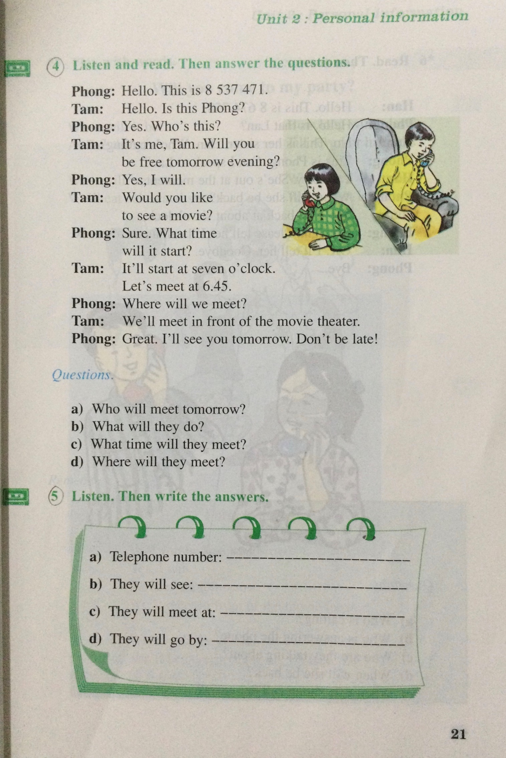**A5. Listen. Then write the answers.**

**EXERCISE**

1. **Choose the word or phrase (A, B, C, or D) that best fits the blank space in each sentence.**
2. __________ is your telephone number?
3. When B. Which C. What D. Why
4. Nga lives ________ 52 Nguyen Dinh Chieu street.
5. at B. on C. in D. by
6. Ba: Where will we meet? -Nam:______ the movie theater.

A. In front B. Next C. In front of  D. Before

1. **Use the correct word form given in each sentence**
2. Orange juice is ____________________________ than coffee. (good)
3. I am ____________________________ than my brother. (short)
4. Her mother is ____________________________ than her father. (young)
5. May I ask you a _____________________________ question? (person)
6. Please ____________________________ me when there are test results. (information)
7. **Cloze test**

Let me tell you something about my family. My father is sixty four. He’s a lot older (10) __________my mother. She is (11) ___________ fifty one. Dad has his own business. Mum helps him (12)_______the business .I have two brothers and (13)__________sisters, (14) __________ are eight of us altogether in my family . I love my (15) __________family very much.

1. A. then B. than C. of D. with
2. A. too B. only C. about D. also
3. A. with B. by C. about D. for
4. A. three B. thirteenth C. thirteen D. third
5. A. their B. theirs C. there D. they
6. A. biger B. big C. bigger D. biggest
7. **Rearrange the words or phrases in the correct order.**
8. next Thursday morning / Lan / an English test / will have /.

🡪

1. is / What / telephone number / your /?/

🡪

1. her classmate / she is calling / Now / to /.

🡪

1. in front of / tomorrow /the cinema / We will meet /.

🡪

**THE END**

**Tiết 2- UNIT 2: PERSONAL INFORMATION**

**B. MY BIRTHDAY**

**B1. CÁC NGÀY TRONG THÁNG**

First = 1st: ngày thứ nhất eleventh: 11th twenty- first: 21st thirty- first: 31st

Second : 2nd: ngày thứ 2 twelfth: 12th twenty- second: 22nd

Third: 3rd thirteenth: 13th twenty- third: 23rd

Fourth: 4th fourteenth: 14th twenty- fourth: 24th

Fifth: 5th fifteenth: 15th twenty- fifth: 25th

Sixth: 6th sixteenth: 16th twenty- sixth: 26th

Seventh: 7th seventeenth: 17th twenty- seventh: 27th

Eighth: 8th eighteenth: 18th twenty- eighth: 28th

Ninth: 9th nineteenth: 19th twenty- ninth: 29th

Tenth: 10th twentieth: 20th thirtieth: 30th

**MONTHS IN A YEAR (CÁC THÁNG TRONG NĂM)**

January : tháng 1

February : tháng 2

March: tháng 3

April: tháng 4

May: tháng 5

June: tháng 6

July: tháng 7

August: tháng 8

September: tháng 9

October: tháng 10

November: tháng 11

December : tháng 12

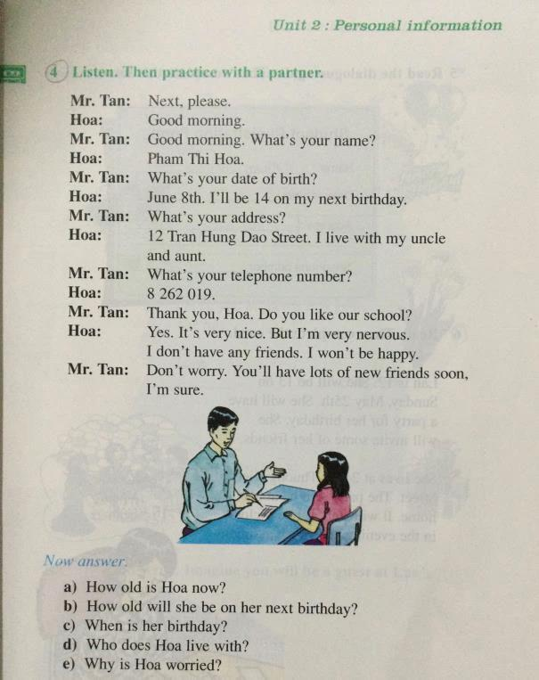**B4**

**VOCABULARY**

1. date of birth: ngày sinh

2. birthday: sinh nhật

3. nice (a.): tốt, giỏi

4. nervous (a.): căng thẳng, lo lắng

5. Sure (a.): chắc chắn

6. worry (v, n.): lo lắng, sự lo lắng

🡪 worried (a.): cảm thấy lo lắng

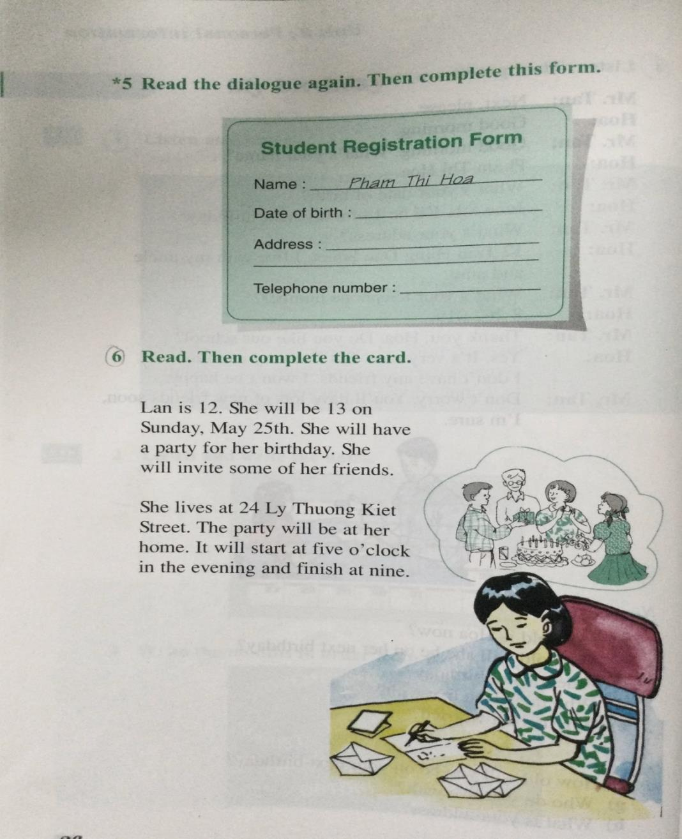**B6**

**VOCABULARY**

1. invite (v.) : mời

🡪 invitation (n.) : lời mời

2. start (v.) : bắt đầu

3. finish (v.) : kết thúc

**PREPOSITIONS (CÁC GIỚI TỪ: IN,ON, AT)**

* on+ day (on Tues**day**, on Mon**day**, on my birth**day,** on June **8th**)
* in+ month (in March, in June)
* in+ year (in 2020, in March 2020)
* in the morning, in the afternoon, in the evening
* at+ địa chỉ (Số nhà+ tên đường) (at 12 Tran Hung Dao Street)
* at+ giờ (at 5 o’clock)

**EXERCISE**

**I. Fill in the blank with a correct preposition: (điền giới từ phù hợp)**

1. Viet lives ________ his uncle and aunt.

2. Her birthday is ______________ October 17th.

3. Our party will be ___ ten o'clock to half past eleven___ the morning___ Sunday.

4. Trung will have a party ________ her birthday _______ home.

5. They often go swimming ______ Sunday.

6. We are playing chess _____________ the moment.

7. It often rains ________ July.

**THE END**